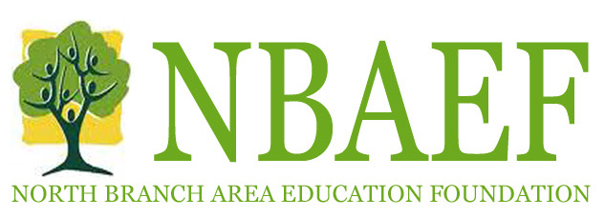

Grant Application Guidelines

Mission Statement:
“Dedicated to enhancing student opportunities to achieve excellence”

Grant Eligibility Criteria and Guidelines:

Grants are available from October 1 though 11:59pm December 15 from the school district Communications Director and at bnaef.org

Grants without all needed signatures and grants turned in late will not be considered.

The North Branch Area Education Foundation (NBAEF) funds projects that:
- Are innovative and enrich or supplement teaching efforts/learning activities that directly benefit students
- Develop learning opportunities not usually possible within the normal school budget
- Are clearly defined and have clearly stated purposes, student performance outcomes, methods and procedures
- Are realistic and educationally sound, with specific materials, resource personnel, tentative schedules and completion dates
- Include an evaluation and reporting plan focusing on achievement of designated student learning outcomes suitable to the nature of the project
- Include a budget request that is reasonable, sufficiently detailed and lists any other sources of income

Preference will be given to projects that:
- Have unique or innovative components (i.e., pilot projects, model programs, experimental efforts and creative programs to enhance the educational experience)
- Are new and have never been funded through the school district budget
- Require start-up support rather than ongoing funding (applicants may apply for additional funding in another calendar year, but should not rely on NBAEF for any subsequent funding)
- Enhance the learning experience for larger numbers of students

Projects are ineligible that:
- Involve the establishment of a permanent foundation or trust, or the creation of a permanent interest-bearing account
- Request funds for other organizations that are themselves fundraisers
- Request funds for any political organization
- Are for events that have already taken place
- Include any liability for the NBAEF except for the monetary amount of the grant
- Do not have all appropriate signatures including technology approval if needed
- Salaries, lodging, meals, and transportation are typically not funded.

Contact the NBAEF at: contact@NBAEF.org with any questions.

GRANT APPLICATION CHECKLIST

Please make sure that you have included:

- ___North Branch Area Education Foundation Grant Application
- ___Project Summary
- ___Project Budget
- ___Project Evaluation and Acknowledgment
- ___All appropriate signatures secured
- ___Technology approval if the grant requires technology
- ___Deadline December 15 at 11:59pm
- ___Notification by January 31

Please return completed application and supporting documents to:

Pat Tepoorten
North Branch Area Education Center

Grants may be turned in electronically or as a hard copy.

