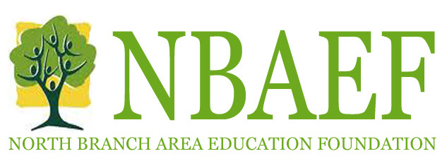

North Branch Area Education Foundation Grant Application
Please Type Your Application

Applications are accepted October 1-December 15 (11:59pm) each year
Grant applications will be reviewed in January with notification in early February.

Please provide all information requested; failure to submit a complete application may result in denial of the application.

Applicant (Primary Contact):
Applicant School: Applicant Title (Subject/Grade):
Applicant School Address:
Applicant Telephone: Applicant Email:
Second Contact (if applicable): Include Name, Title, School, Telephone, and Email:

PROJECT TITLE:
Project Start Date: Project Completion Date:

By signing, the grant applicant assures that they have discussed this proposal with their principal/director, and technology, have verified that funding for the project is not available from normal school or district sources, will commit the time needed to conduct the work described in this application, and will complete the required status and final report by designated date. By signing, principal/director/technology assures that the project applicant has approval to implement the project, the project meets the overall mission of the site or program, and applicant will be available to present the information to the board of directors on designated date.

Applicant’s signature Date

Principal / Director signature Date

Technology Signature if needed Date

NBAEF use only:
Date Rec’d:____________ Approved: Yes______ No_______ Date Approved:_________________
Grant Amount:______________________________________ Date check issued________________

PROJECT SUMMARY

Project Title:

Project Summary (200 words max):

What is the need or rational for the project:

Who are the learners to be affected

How many learners would be affected (primarily):

Describe the activities of the project and provide a timetable of events:

How will this project provide new and/or unique learning opportunities?

Describe specific student learning outcomes of the project, both measurable and intrinsic (know, do, value, create), and how these outcomes will be reached:

PROJECT BUDGET

Total Project Budget:
Amount requested from NBAEF:

Project Budget Specifics (you may attach your own format)
Provide specific information about costs, which may include materials, equipment, supplies, transportation and other expenses. Be advised that NBAEF typically does not underwrite meals, lodging salaries, and the like.

Expense | Description | Estimated Cost ($)

Total project costs | $
Amount requested from NBAEF | $
Amount requested from other sources | $

Other Funding Sources and/or Cooperating Organization:
If this project involves a cooperating organization, please attach a letter of participation that states the cooperating organization’s contributions and responsibilities. Such collaboration is desired but not required. If there are other funding sources involved with this project, please list.

Name of organization:

Amount committed to project:

PROJECT EVALUATION AND ACKNOWLEDGMENT

Describe how this project will be evaluated. How will you evaluate the degree to which the specific learning outcomes have been achieved? Include a description of how and with whom the results of the evaluation will be shared. Note: Please provide NBAEF a copy of the evaluation and any pictures or publications.

In what ways will you be able to publicly acknowledge support provided by NBAEF?

Upon your projects implementation or completion, who will be able to present a 15 minute summary of the project to the NBAEF Board of Directors at a grant presentation scheduled in the fall by the Board of Directors. Every effort will be made to schedule a date convenient for all.

Name ________________________________________

Contact Information _________________________________________________________________

Please describe the project in 2-4 sentences. *This will be used for NBAEF promotional materials.

GRANT APPLICATION CHECKLIST: Please see checklist on Grant Guidelines

Please return completed application and supporting documents to:

Pat Tepoorten
North Branch Area Education Center

Updated April 2014

